Name: A.Reddy Sulochana
Reg.No: 192372370

Exp.No.12 Tic Tac Toe Game
01.08.26

Aim:
To implement the Tic Tac Toe game using Python, allowing two players to play alternately and determining the winner or declaring the match as a draw based on the game rules.

Algorithm:
- Start the program.
- Create an empty 3×3 game board.
- Display the game board to the players.
- Assign Player X and Player O to play alternately.
- Accept the position entered by the current player.
- Check whether the selected position is empty.
- Place the player's symbol on the board and display the updated board.
- Check whether the current player has achieved any winning combination.
- If a player wins, display the winner and end the game; otherwise, if all positions are filled, declare the match as a draw and stop the program.

Program:
board = [" "] * 9
win = [
[0,1,2], [3,4,5], [6,7,8],
[0,3,6], [1,4,7], [2,5,8],
[0,4,8], [2,4,6]
]
def display():
print(board[0:3])
print(board[3:6])
print(board[6:9])
def check(player):
for i in win:
if board[i[0]] == board[i[1]] == board[i[2]] == player:
return True
return False
for i in range(9):
display()
player = "X" if i % 2 == 0 else "O"
pos = int(input(f"Player {player}, Enter position (1-9): ")) - 1
if board[pos] == " ":
board[pos] = player
else:
print("Position already occupied")
continue
if check(player):
display()
print(f"\nPlayer {player} Wins!")
break
else:
display()
print("\nMatch Draw")
Input:
Player X: 1
Player O: 5
Player X: 2
Player O: 9
Player X: 3
Output:
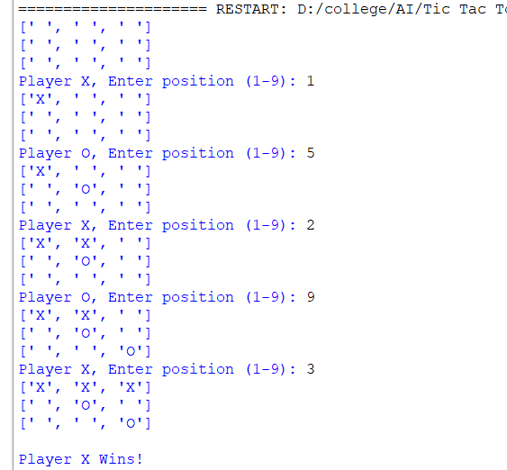

Result:
Thus, the Tic Tac Toe game was implemented successfully using Python. The program accepted moves from two players, displayed the updated game board after each move, identified the winner correctly, and terminated the game when a player won or when the match ended in a draw.

